

Audio ojačevalnik »PIZp«

Simon LIPPOVŠEK
Razred: E4.A

Šolsko leto 2022/2023

Datum: 24.10.2022

Kazalo:

- Naslov vaje
- Besedilo naloge
- Električna oziroma vezalna shema
- Tiskano vezje v merilu 1:1
- Kosovnica
- Lasten komentar

Besedilo naloge
Dokumentacija za audio ojačevalnik in laserski prenos zvoka..

Električna oz. vezalna shema audio ojačevalnika
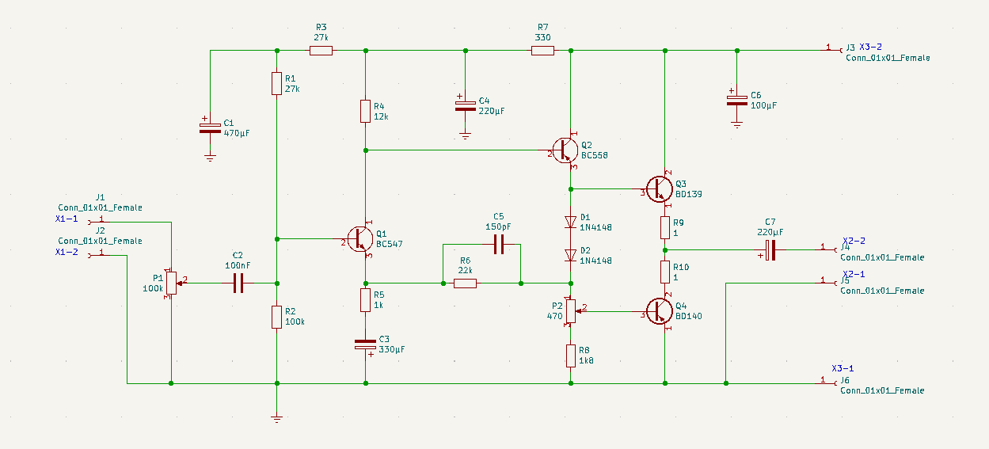

Električna oz. vezalna shema
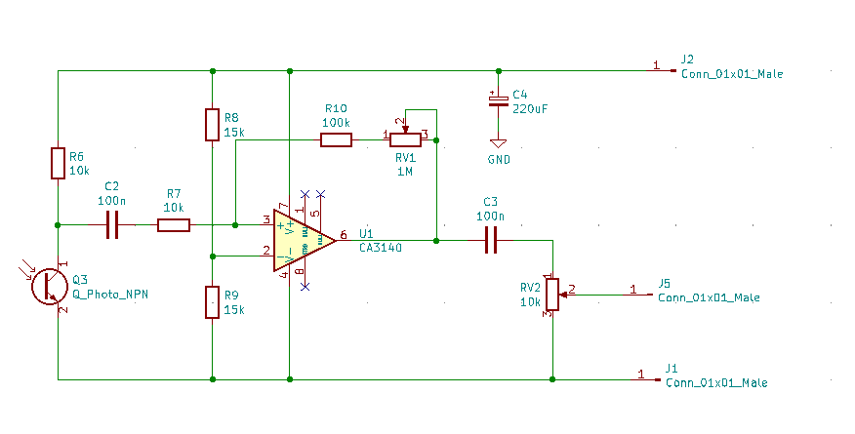

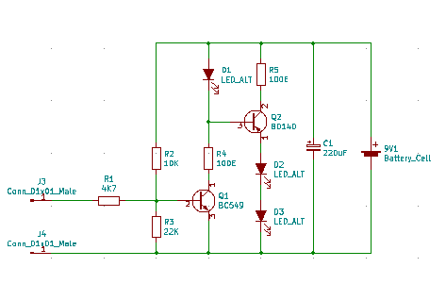

Tiskano vezje v audio ojačevalnika
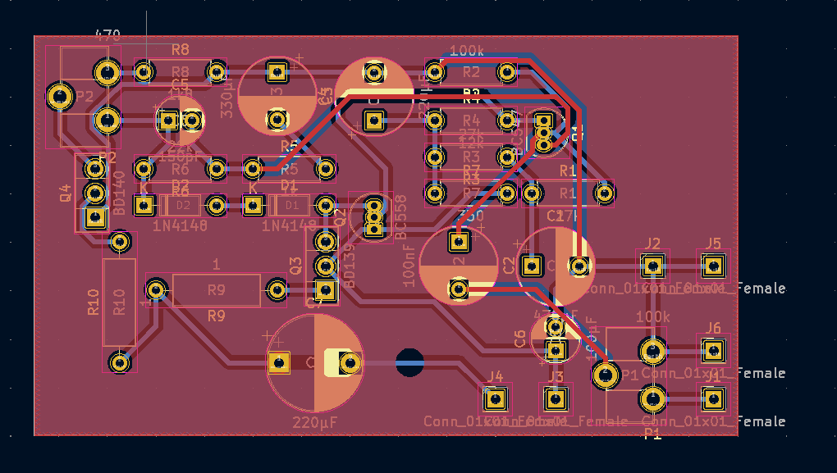
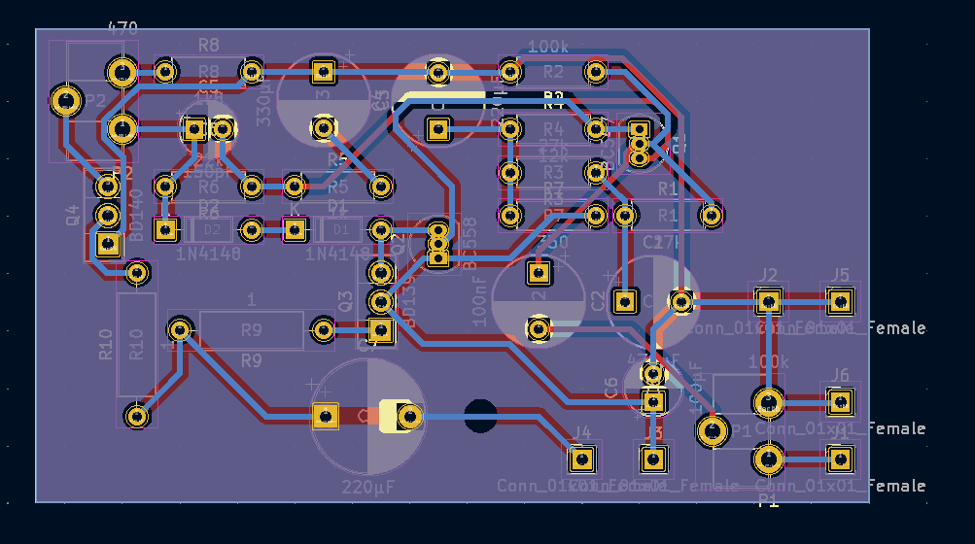

Tiskano vezje
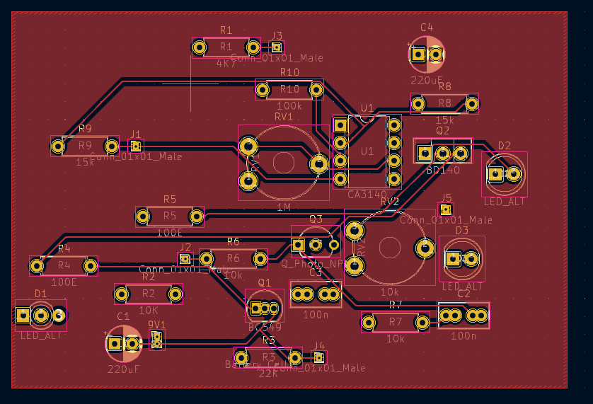
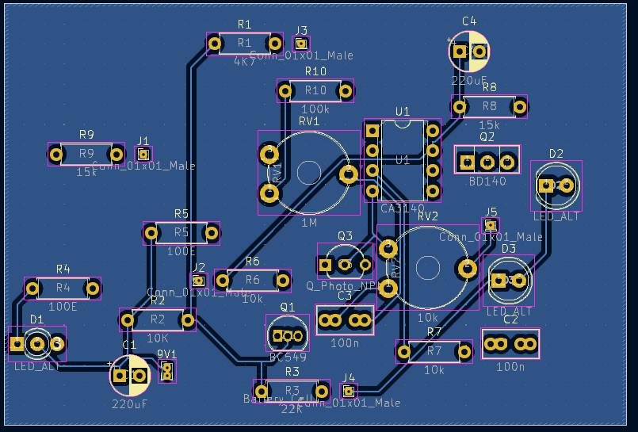

Blok shema

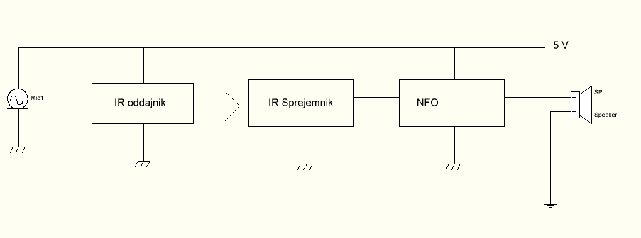

Kosovnica audio ojačevalnika
Ime elementa | Vrednost | Površina
C1 | 470µF | Capacitor_THT:CP_Radial_D8.0mm_P5.00mm
C2 | 100nF | Capacitor_THT:CP_Radial_D8.0mm_P5.00mm
C3 | 330µF | Capacitor_THT:CP_Radial_D8.0mm_P5.00mm
C4 | 220µF | Capacitor_THT:CP_Radial_D8.0mm_P5.00mm
C5 | 150pF | Capacitor_THT:CP_Radial_D5.0mm_P2.50mm
C6 | 100µF | Capacitor_THT:CP_Radial_D5.0mm_P2.50mm
C7 | 220µF | Capacitor_THT:CP_Radial_D10.0mm_P7.50mm
> D1, D2 | 1N4148 | Diode_THT:D_DO-35_SOD27_P7.62mm_Horizontal
> J1-J6 | Conn_01x01_Female | Connector_PinHeader_2.54mm:PinHeader_1x01_P2.54mm_Vertical
P1 | 100k | Potentiometer_THT:Potentiometer_ACP_CA9-H5_Horizontal
P2 | 470 | Potentiometer_THT:Potentiometer_Piher_PT-10-H05_Horizontal
Q1 | BC547 | Package_TO_SOT_THT:TO-92_Inline
Q2 | BC558 | Package_TO_SOT_THT:TO-92_Inline
Q3 | BD139 | Package_TO_SOT_THT:TO-126-3_Vertical
Q4 | BD140 | Package_TO_SOT_THT:TO-126-3_Vertical
> R1, R3 | 27k | Resistor_THT:R_Axial_DIN0207_L6.3mm_D2.5mm_P7.62mm_Horizontal
R2 | 100k | Resistor_THT:R_Axial_DIN0207_L6.3mm_D2.5mm_P7.62mm_Horizontal
R4 | 12k | Resistor_THT:R_Axial_DIN0207_L6.3mm_D2.5mm_P7.62mm_Horizontal
R5 | 1k | Resistor_THT:R_Axial_DIN0207_L6.3mm_D2.5mm_P7.62mm_Horizontal
R6 | 22k | Resistor_THT:R_Axial_DIN0207_L6.3mm_D2.5mm_P7.62mm_Horizontal
R7 | 330 | Resistor_THT:R_Axial_DIN0207_L6.3mm_D2.5mm_P7.62mm_Horizontal
R8 | 1k8 | Resistor_THT:R_Axial_DIN0207_L6.3mm_D2.5mm_P7.62mm_Horizontal
> R9, R10 | 1 | Resistor_THT:R_Axial_DIN0309_L9.0mm_D3.2mm_P12.70mm_Horizontal

Kosovnica 2
Ime elementa | Vrednost | Površina
"9V1" | "Battery_Cell" | "Connector_PinHeader_1.00mm:PinHeader_1x02_P1.00mm_Vertical"
"C1" | "220uF" | "Capacitor_THT:CP_Radial_D5.0mm_P2.50mm"
"C2" | "100n" | "Capacitor_THT:C_Rect_L7.0mm_W3.5mm_P2.50mm_P5.00mm"
"C3" | "100n" | "Capacitor_THT:C_Rect_L7.0mm_W3.5mm_P2.50mm_P5.00mm"
"C4" | "220uF" | "Capacitor_THT:CP_Radial_D5.0mm_P2.50mm"
"D1" | "LED_ALT" | "LED_THT:LED_D3.0mm-3"
"D2" | "LED_ALT" | "LED_THT:LED_D5.0mm"
"D3" | "LED_ALT" | "LED_THT:LED_D5.0mm"
"J1" | "Conn_01x01_Male" | "Connector_PinHeader_1.00mm:PinHeader_1x01_P1.00mm_Vertical"
"J2" | "Conn_01x01_Male" | "Connector_PinHeader_1.00mm:PinHeader_1x01_P1.00mm_Vertical"
"J3" | "Conn_01x01_Male" | "Connector_PinHeader_1.00mm:PinHeader_1x01_P1.00mm_Vertical"
"J4" | "Conn_01x01_Male" | "Connector_PinHeader_1.00mm:PinHeader_1x01_P1.00mm_Vertical"
"J5" | "Conn_01x01_Male" | "Connector_PinHeader_1.00mm:PinHeader_1x01_P1.00mm_Vertical"
"Q1" | "BC549" | "Package_TO_SOT_THT:TO-92_Inline"
"Q2" | "BD140" | "Package_TO_SOT_THT:TO-126-3_Vertical"
"Q3" | "Q_Photo_NPN" | "Package_TO_SOT_THT:TO-92L_Inline_Wide"
"R1" | "4K7" | "Resistor_THT:R_Axial_DIN0207_L6.3mm_D2.5mm_P7.62mm_Horizontal"
"R2" | "10K" | "Resistor_THT:R_Axial_DIN0207_L6.3mm_D2.5mm_P7.62mm_Horizontal"
"R3" | "22K" | "Resistor_THT:R_Axial_DIN0207_L6.3mm_D2.5mm_P7.62mm_Horizontal"
"R4" | "100E" | "Resistor_THT:R_Axial_DIN0207_L6.3mm_D2.5mm_P7.62mm_Horizontal"
"R5" | "100E" | "Resistor_THT:R_Axial_DIN0207_L6.3mm_D2.5mm_P7.62mm_Horizontal"
"R6" | "10k" | "Resistor_THT:R_Axial_DIN0207_L6.3mm_D2.5mm_P7.62mm_Horizontal"
"R7" | "10k" | "Resistor_THT:R_Axial_DIN0207_L6.3mm_D2.5mm_P7.62mm_Horizontal"
"R8" | "15k" | "Resistor_THT:R_Axial_DIN0207_L6.3mm_D2.5mm_P7.62mm_Horizontal"
"R9" | "15k" | "Resistor_THT:R_Axial_DIN0207_L6.3mm_D2.5mm_P7.62mm_Horizontal"
"R10" | "100k" | "Resistor_THT:R_Axial_DIN0207_L6.3mm_D2.5mm_P7.62mm_Horizontal"
"RV1" | "1M" | "Potentiometer_THT:Potentiometer_Piher_PT-10-V10_Vertical"
"RV2" | "10k" | "Potentiometer_THT:Potentiometer_Piher_PT-10-V10_Vertical"
"U1" | "CA3140" | "Package_DIP:DIP-8_W7.62mm"
"9V1" | "Battery_Cell" | "Connector_PinHeader_1.00mm:PinHeader_1x02_P1.00mm_Vertical"
"C1" | "220uF" | "Capacitor_THT:CP_Radial_D5.0mm_P2.50mm"
"C2" | "100n" | "Capacitor_THT:C_Rect_L7.0mm_W3.5mm_P2.50mm_P5.00mm"
"C3" | "100n" | "Capacitor_THT:C_Rect_L7.0mm_W3.5mm_P2.50mm_P5.00mm"

Komentar
Naučil sem se uporabljati nov program LtSpace za simuliranje vezji.

